Operation Manual
Part I: Before Going to the Lab
- RPM/IPM generation
  - Generate RPM/IPM with Matlab code by KaiHsun, choose the first 24 pairs
- Formal Experiment Gcode generation
  - Use Gcode for the most recent tool, change the RPM and IPM with “search” and “replace” in Matlab. There are 48 Gcode files to be modified. The microscope position can also be changed, but it is recommended to modify the position of the microscope in the CNC machine. So, the line “G20G1X-2.2Z2.62F75” should stay the same for all Gcode files of all tools.
- Pre-Trial Gcode generation
  - When formal trial Gcode files are obtained, Pre-Trial Gcode files are obtained by modifying the cutting depth of the first 8 formal trial Gcode files. It is also done by replacing “Z-0.0160” with “Z-0.0080” with Matlab replace function.
Part II: Workpiece Preparation
- Prepare (Buy/Cut) 6 inch by 6 inch by 0.5 inch Al6061 board
  - The side should be over 6 inches but should not be under 6 inches, otherwise trouble would occur. The thickness can be anything near 0.5 inch.
- Generate Gcode for drilling in Carbide Create
  - The center of the four holes should be half inch away from the sides. The smaller holes have 0.3 inch diameters and are through. The larger holes have 0.5 inch diameters and are down the surface for 0.25 inch.
  - Note that “pocket” is the function to be used instead of “drill”.
- Clamp the board with two clamps
  - Note that 6 inch is beyond the max of the clamp. The center block should be taken away while the end face of the screw should be in contact with our workpiece. Make sure nothing is under the holes. Otherwise the clamp may be also drilled in.
  - Leave enough space on the lower left corner of the board so that space is left for probing.
  - Note that when tightening the screws on the clamp, a force (better bodyweight) should be pressing the board down since the screws would be trying to lift the board down.
  - When clamped, check level with the bubble tool across the surface. In addition, try to press down or lift up the board with force, it should stay in position.
- Probe the board
  - Check if the board is level before probing.
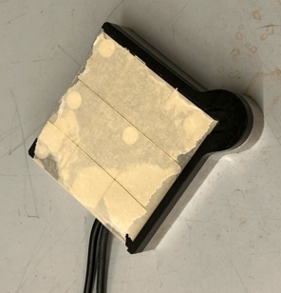
  - It is advised to use two layers of tape to tape the probe tool to the board. This guarantees the stability and extra room for later adjustments.

  - After probe, don’t change tool right away. Remove the probe tool and go to “JOG” mode. First go to X0Y0Z0.1 to see if X and Y are correct (they usually are). Second, find an arbitrary position like X1Y1, then slowly approach Z0. Remember to put a small piece of paper between the tip pf the tool and the board. Keep sliding the piece of paper around until the tip and the board restrict the piece of paper. Stop going down and record the height. Repeat this for at least five positions: near the four corners and somewhere at the center. Find the highest point of the points, manually set that height to be Z0.

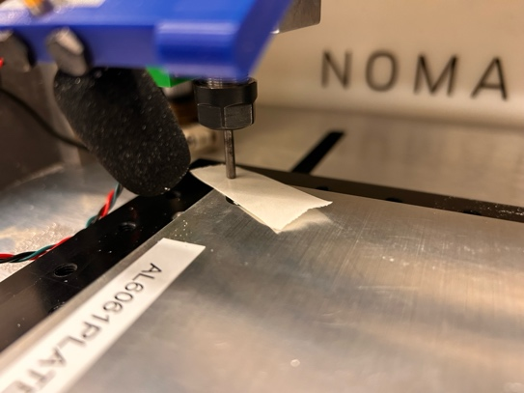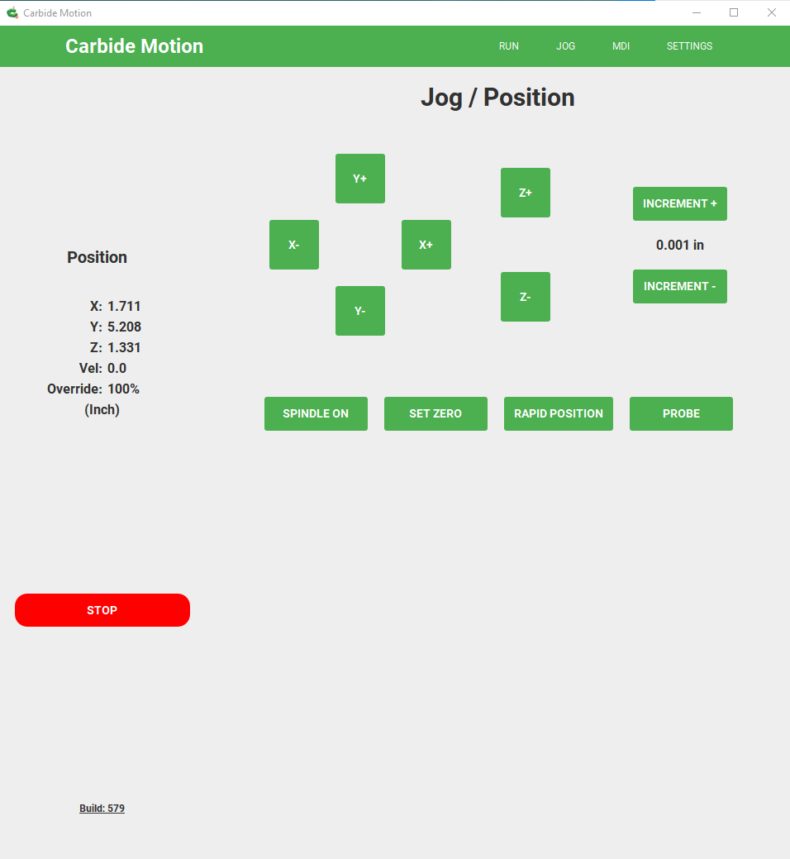
- Run Gcode and drill the board
  - Sometimes the machine will not be able to drill through, make a new Gcode to finish drilling.
- Smoothen the edges
  - Use the cone-like tool to wear down the sharp edges.
Part III: Machine Preparation
- Connect everything, turn on machine, check all connections
  - Log in the computer, connect the USB to the computer, turn on the CNC machine, turn on the DAQ, turn on the amplifier, turn on the light sensor breadboard, turn on the microscope.
- Check sensors
  - Use DQI mode in Carbide Motion, “M03S24000”/“M03S0”, turn on and off the spindle. See if the function of the light sensor is working well. If not, remove the green block with light sensor and accelerometer and adjust the position of the light sensor.
  - Run the sensor check script, slightly knock at the accelerometer and clap near the microphone. Check the plot to see if the four channels’ output looks right.
  - Move the spindle to above the microscope, check microscope output with Matlab script. Check if the microscope is level.
Part IV: Pre-Trial Running
Pre-Trial Gcode is the Gcode modified from formal experiments Gcode. If Pre-Trials run fine, it is very likely that the formal experiments will run fine.
- Experiment running cycle

- Data plot check
- Also, running the Pre-Trials are preparing the right depth of the board. This prepares the Main Trial side and the first 8 SR Trials. There are 40 more SR trials to be prepared, or to be cut to 0.008 inch depth.
Part V: Formal Experiments
- Take new tool image * 9 in all positions
- Prepare the Word file: “DataCollectionT5.docx”
- Experiment running cycle
  - Load New File
  - “Start Job” “Start” “Run” “Resume”
  - Wait till finish
  - Vacuum the chips
  - Retake images
  - Check Data
  - Change “Image For Loop” (i+?)*2
  - Back to “Load new file”
- Data plot check （every few trials）

Part VI: Closing Up
Part VII: Image Alignment
Part VIII: Wear Measurement
Part IX: Surface Roughness Measurement

